

SCHOOL OF SCIENCE AND TECHNOLOGY
MOBILE INTERACTIVE SYSTEMS
MODULE CODE: ISYS40151

Mobile Interactive application Report

SUBMITTED
BY
PURNIMA MALNEEDI
STUDENT ID: N0768969
SUBMITTED TO
Dr Eiman Kanjo
Submission Date: 09-03-2018

Contents

1. Introduction and background 3
2. Design 4
3. Implementation 6
4. Testing 8
5. Critique 9
6. References 10

Introduction and background
In this age of technology development, it is simply impossible to imagine a resting or working process without the use of gadgets. The internet and mobile devices have found revolutionary ways to connect people, entertain them and let them exchange information.
The current global mobile phone usage is 4 billion, which is equivalent to around half of the world’s population. A vast majority of these mobile phone users are so busy to even read the daily newspaper or pick up a recipe book like we used to do probably a decade ago, the reason being that all the information they need is readily available on the click of a button either in a browser or in an installed app.
Stable internet access be it Wi-Fi or 4G has played a major role in users making the mobile phone their constant companion. There are custom designed apps for instant messaging, news, workouts etc. The simpler the application, the easier to understand and the more popular it becomes. Interface and user experience are the first things to be considered when building a mobile application.
This android application focuses on Indian food recipes. It is user-friendly and facilitates navigation through popular regions and find associated delicacies and their recipes along with a link to the YouTube video. This saves them the hassle of scouring the internet for their favorite dishes. Another advantage of having all recipes being in an app is that it helps organize and manage your grocery shopping.

Design
This section provides the overview about the system requirements, features and about problem statement of the application. And further give more information through flow chart and discuss the steps that implemented for testing the application.
Problem Statement:
In recent times, many people around the globe doesn’t know the ingredients for recipes, method of cooking the recipes. And, many people want to try different kind of recipes available around the globe. Cooking different kind of recipes is stress buster for few people. For example, people who stays away from home not sure about the ingredients and preparation method of recipes. In this digitalized world those people really want these kind of Handy cooking apps. Where people can find the required ingredients and accurate quantity of ingredients. And allow foodie people to try different kind of recipes available in App. Due to this so many people will explore these kinds of Apps. Based on these problems facing by people who love to cook food, then thought about my app. And stated in Aims and objectives that how this App will fix the problems facing by foodies.
System Requirements:
To design and run this application we need a system with below tools.
- Android Studio
- A smart phone with android OS
Core Java language is used to develop the mobile activities and XML is used for application design.
Application Features:
The key features of the application explained below.
- Varieties of Food Recipes which are famous across different regions in India.
- Each Recipe is provided with several information like Recipe type, Ingredients and step by step making instructions.
- A recipe making video also added for each recipe, this video will be redirected to YouTube.

Flow Chart:
The below flow chart explains the program flow of the application.
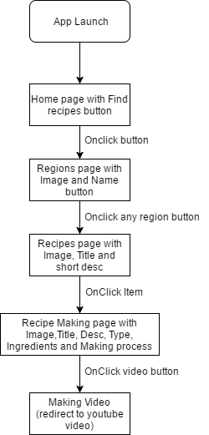
Testing Method:
Based on the design usability feedback the Indian Food and Recipe will be tested. To achieve this, we are using both functional and non-functional testing methods.
Non-Functional testing: To test app in this method. App given to different people for usage and collected the feedback form the people. Asked the people for both positive and negative. And asked for provide suggestion for which they feel to implement for more user friendly.
Functional Testing: This method of testing done by using the different kind of android version and different kind of available devices. This testing is to make sure how app is working on different platforms.

Implementation
I have created 8 Java class activities and 8 XML layout activities to create this application. Each activity refers to the one screen in the mobile app.
To start with the home screen of the App, the application launches with a nice background image and one button ‘Find Recipes’. This is designed in the ‘activity_main.xml’ file. I have used
‘<ImageView android:src="@drawable/homescreen"/>’ to display the background image and ‘<Button>’ tags with some properties (like Id, size, color and alignment etc.). This XML page will be loaded on to the app using ‘setContentView’ in the ‘MainActivity.Java’ file. This code is shown below.
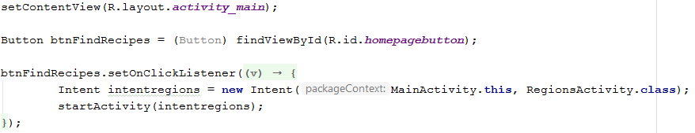
The ‘Find recipes’ button click on the home page launches the regions Activity page.
For this I have used ‘setOnClickListener’ used to open regions page using Intent.
The second page (regions page) shows different regions across India, for this page I have used ‘LinearLayout’ and ‘TableRow’ to display the region image and a button (region name) next to Image as shown below. I have faced a problem here as I have got nearly 5 regions it is not correctly fitting in to small screen. So I have used ‘scrollview’ to solve the problem.
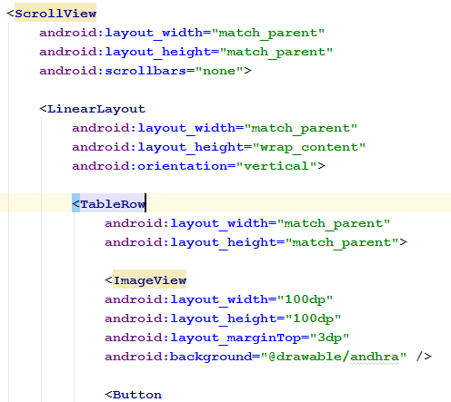

Each button in the regions page will open the next Recipe activity page. For example, when ‘Andhra Pradesh’ button clicked in the regions page it will open ‘AndhraRecipiesActivity’ activity there I have displayed all the different varieties of recipes with in that region. For this I have used below code.
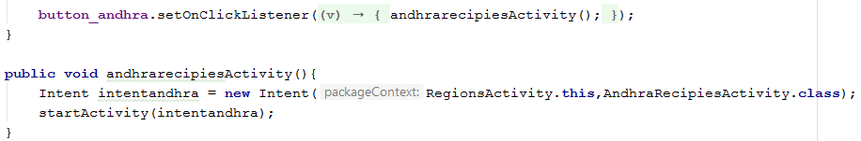
This code is used for all button clicks in the region page to go to corresponding regions activity.
The 3rd page is recipes page. I have created separate XML and Java files for each region, because each region has got different recipes. So, I have created 5 xml and 5 java files. However, all the pages use same code with its own recipe details.
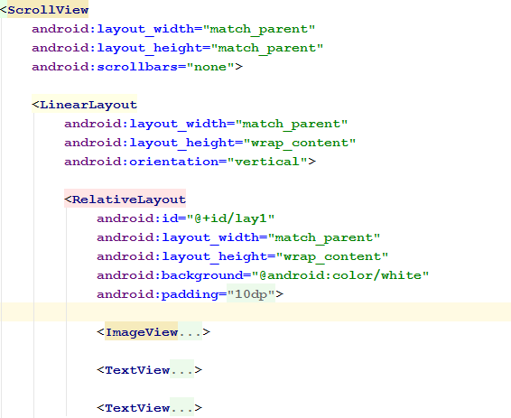
As shown above I have used a ‘RelativeLayout’ with ‘ImageView’ (to display item image) and 2 ‘Textview’ (to display Item name and short desc) to display one item. Same code is repeated in the xml for each item. This recipes page is called by the corresponding ‘Recipeactivity’ to display all the items. OnClick on Item will then open another activity (RecipeMakingActivity) to display the full recipe details like type, ingredients, making instructions and a button to open the YouTube video. I have used ‘RecipeMakingActivity‘ to dynamically display the item recipe details based on the request coming from the Recipes page. I have used ‘Intent.putExtra’ to pass the values between two activities. Please see the below code.
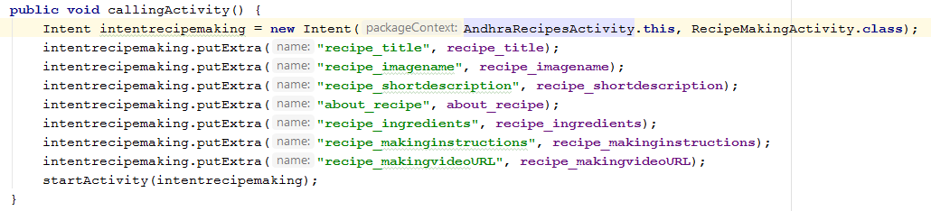
On each item click in the recipe page pass the item details to the recipe making activity page. To get these item details in the recipe making page I have used ‘getIntent().getStringExtra(“recipe_title”)’ to get the corresponding values. Here I have faced a challenge of setting back ground image dynamically. After doing some research I found ‘getResources.getIdentifier’ is used to find image id from image name and then display the image. Here I have also used ‘try catch’ exception handling to set image visibility in case of no image found.
Finally to open the YouTube video upon clicking the button in the recipe making page I have used below code.
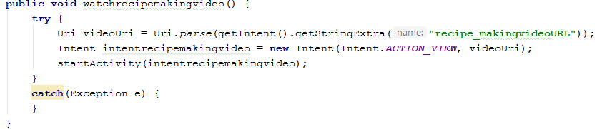

I have also make sure that all the static text (recipe details) is stored in strings.xml file instead of hardcoding in the java files.

Testing
Testing of the application is key to identify any issues with running the application and to check whether application meets with design requirements. Also to confirm each functionality of the app works perfectly.
Following test cases expected to be tested as part of unit testing the application.
Test Case No | Test Case | Expected Outcome | Result
TC001 | Launch the App on Mobile device | App should be launched with no errors. | Success
TC002 | App home screen need to display FIND RECIPES button | Find recipe button should be at the bottom. | Success
TC003 | User should be allowed to tap FIND RECIPES on home screen | Button should be clickable. | Success
TC003-01 | When user taps FIND RECIPES. App should display new screen with Indian Food Recipes header following different regions. | OnClick find recipes should display all the regions with image and region name. | Success
TC003-02 | All the regions and images should be in the same size and aligned properly. | All buttons should be aligned. | Success
TC003-03 | when user taps the any region then new page should be displayed with all the corresponding recipes. | Items should be displayed for each region. | Success
TC003-04 | In the same screen in right column of layout description of the recipe need to be available to user right below the name of recipe. Image should be on left side. | Recipe Image, Name and short description should be displayed for all items. | Success
TC003-05 | App allows the user to tap on each individual recipe | User should be able to tap on any item. | Success
TC003-06 | when user taps on the individual recipe. App need to display the new screen with the name of the recipe as header. | When user click on item new page should be displayed with item name in the header | Success
TC003-07 | Below the Header of the Recipe name. App need to display the corresponding image of the recipe. | Item image should be displayed. | Success
TC003-08 | Below the image small description of recipe should be displayed. | Item description should be displayed. | Success
TC003-09 | Below the description, Recipe Making video link need to be available for user. | A button should be displayed if video URL present for the recipe. | Success
TC003-10 | When user taps on video it should redirect to YouTube to display the video of making process of that corresponding recipe. | OnClick open video button should open corresponding YouTube video. | Success
TC003-11 | Below Recipe Making video link, user able to see About Recipe Section with appropriate information. (Cuisine Course, Diet.) | About recipe details should be displayed. | Success
TC003-12 | Below About Recipe Section, Ingredients section should be displayed with all required ingredients information. | Item Ingredients should be displayed. | Success
TC003-13 | Below Ingredients section, Method section should be displayed. Which should have step by step process for making the recipe | Recipe Preparation method for the item should be displayed. | Success
TC004 | Device will have back button which enables user to go back to see different recipe or home. | Device back button should take user back to the previous screens. | Success
TC005 | Scroll button should allow user to scroll down and watch all the information in that screen. | All the app screens should be scrollable. | Success

All the above test cases performed on different emulators with different screen sizes to make sure that all the screens fit correctly. Also, app is tested on a real android device.

Critique
Finally, I can conclude that my application meets the all requirements that I have expected to do. Though some improvements can be done to reduce the code by removing duplicate or similar code. For example all regions have separate xml and activity page but at the end all behaves same. So instead of 5 different activities I thought there will be some way to achieve this. I am sure I will handle these kinds of situations in my next development programs.

References
- android?, H. (2018). How to set the image from drawable dynamically in android?. [online] Stackoverflow.com. Available at: https://stackoverflow.com/questions/11737607/how-to-set-the-image-from-drawable-dynamically-in-android [Accessed 7 Mar. 2018].
- row, A. (2018). Android two buttons side by side into table row. [online] Stackoverflow.com. Available at: https://stackoverflow.com/questions/18429748/android-two-buttons-side-by-side-into-table-row [Accessed 8 Mar. 2018].
- Vahrehvah.com. (2018). Indian Recipes, Cooking videos, Restaurant & Home Recipes, vegetarian & Non Veg Recipes. [online] Available at: https://www.vahrehvah.com/ [Accessed 5 Mar. 2018].
[Note: All the recipes details copied from the above reference]

